Cylinder Collection Task Wall Light Short
Assembly Instructions
Important Safety Instructions:
- These instructions are provided for your safety. It is very important that they are read carefully and completely before beginning the assembly and installation of this lighting fixture.
- This portable luminaire has a polarized plug (one blade is wider than the other) as a safety feature to reduce the risk of electric shock. This plug will fit in a polarized outlet only one way. If the plug does not fit fully in the outlet, reverse the plug. If it still does not fit, contact a qualified electrician. Never use with an extension cord unless plug can be fully inserted. Do not alter the plug. Do not attempt to defeat this safety feature.
- For your safety and convenience, it is strongly recommended that two people install the lighting fixture.
- This fixture has been rated for up to one (1) 60-watt maximum TYPE A standard incandescent light bulb (not included) or one (1) 5-watt LED light bulb (included) or one (1) 13-watt compact fluorescent light bulb (not included). To avoid the risk of fire, do not exceed the recommended lamp wattage.
- To avoid the risk of fire, do not exceed the recommended wattage.
- This lamp is meant for indoor use.
- Save these instructions.

WARNING:
- To reduce the risk of fire, electrical shock or personal injury, always turn off and unplug the light fixture and allow it to cool prior to replacing light bulb.
- Do not touch bulb when fixture is turned on. Do not look directly at lit bulb.
- Keep flammable materials away from lit bulb.

Pre-assembly:
- Remove all parts and hardware from box along with any plastic protective packaging.
- Do not discard any contents until after assembly is complete to avoid accidentally discarding small parts or hardware.
- For your safety and convenience, assembly by two people is recommended.

TOOLS Required (not included):
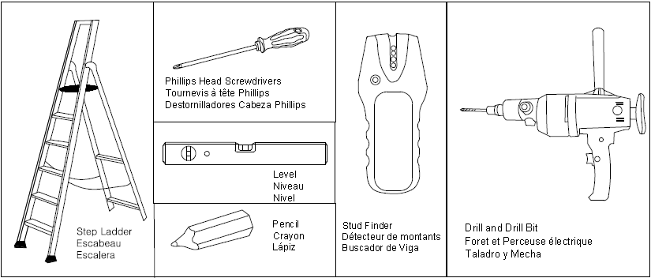

Cylinder Collection Task Wall Light Short
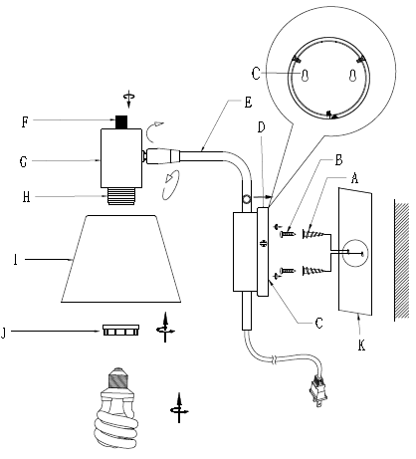
Assembly Instructions

Parts Included:
Back View
(C) Mounting Plate (1)
(D) Canopy (1)
(E) Lamp Arm (1)
(F) Switch (1)
(G) Socket Cup (1)
(H) Socket (1)
(I) Lamp Shade (1)
(J) Socket Ring (1)

Hardware Enclosed:
(A) Wall Anchors (2)
(B) Wall Screws (2)
(K) Paper Template (1)

To assemble:
- This mounting hardware is meant for dry wall/stud mounting only. If walls are concrete, brick or plaster, please consult your local hardware store for assistance. For safety and ease of mounting, installation is recommended using two people.
- Stud mounting is always best, so try to position the Mounting Plate (C) over the studs using the enclosed Paper Template (K). Use a stud finder to locate a stud in desired wall location. If Mounting Plate (C) aligns with stud, only use provided Wall Screws (B). If there is no stud, the Wall Anchors (A) and Wall Screws (B) are both required.
- For Drywall Mounting: Assemble and install the Wall Anchors (A) and Wall Screws (B) using the steps as outlined in Section “FOR DRYWALL MOUNTING” below.
- For Mounting to Joist: Assemble and install the Wall Screws (B) using the steps as outlined in Section “FOR MOUNTING TO JOIST” below.
- After properly assemble the Wall Anchors (A) and Wall Screws (B) onto the wall, install the lighting fixture onto the wall using the steps as outlined in Section” Install the Light Fixture onto the Wall”

Cylinder Collection Task Wall Light Short
Assembly Instructions
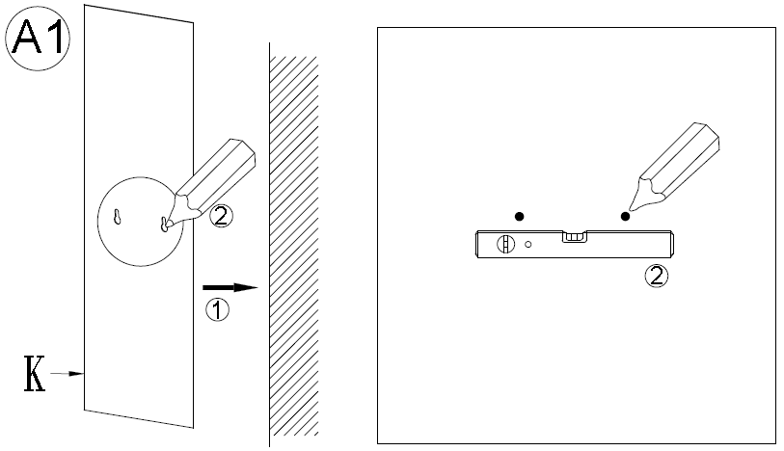
For Drywall Mounting:
- Place the Paper Template (K) against the wall at the desired hanging location.
- Mark the mounting location of the 2 holes of Paper Template (K) onto the wall using a pencil. Use a carpenter’s level to ensure a level installation.
- MAKE SURE THAT A POWER OUTLET IS REACHABLE BY THE CORD without straining the cord.

Use a Phillips Screwdriver to insert the Wall Anchors (A) at the marked keyhole locations. Do not “push” or drive the Wall Anchors (A) into the wall, it is designed to bore into the wall like a drill bit. Slowly turn the Wall Anchors (A) clockwise while applying pressure until the flange just touches the wall.

A

A
B
Use the Phillips screwdriver to secure the Wall Screw (B) into each installed Wall Anchor (A). Rotate the Wall Screw (B) clockwise until the screw head is about 3/8 inches from the wall.

Cylinder Collection Task Wall Light Short
Assembly Instructions
For mounting to joist
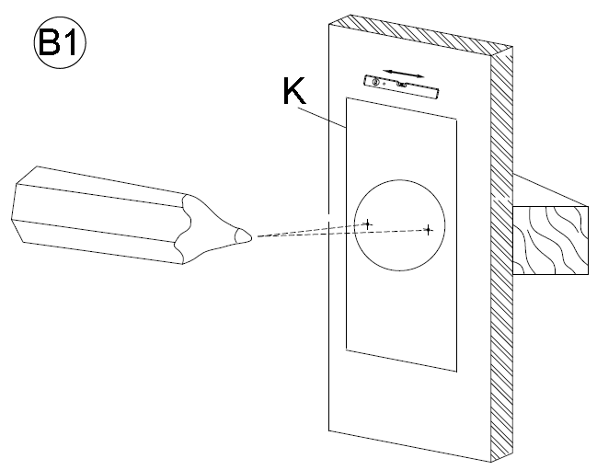

Place the Paper Template (K) against the wall at the desired hanging location. Mark the mounting location of the 2 holes of Paper Template (K) onto the wall using a pencil. Use a carpenter’s level to ensure a level installation. MAKE SURE THAT A POWER OUTLET IS REACHABLE BY THE CORD without straining the cord.

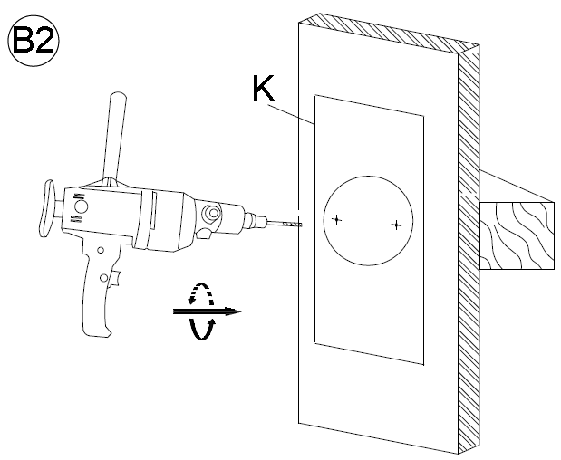

Use the Phillips screwdriver to secure the Wall Screws (B) into each drilled hole. Rotate the Wall Screw (B) clockwise until the screw head is about 3/8 inches from the wall.

Pre-drill pilot holes at the marked locations. This will make installing the Wall Screws (B) onto the wall easier.

B

B

Cylinder Collection Task Wall Light Short
Assembly Instructions
Install the Light Fixture onto the Wall:
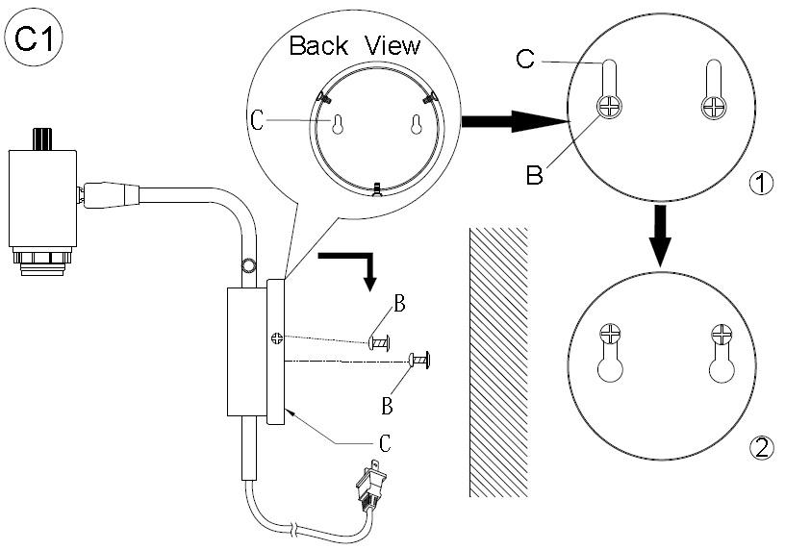

- Preferably with the help of another person, lift the lighting fixture against the wall so the two mounting keyholes on the Mounting Plate (C) align with and engage the protruding screw heads (B).
- Gently lower the lighting fixture so that the screws support its full weight. Make sure that each screw (B) is completely engaged with its keyhole before releasing the fixture.
Note: Some readjustment of the screws may be needed to ensure a secure fit against the wall.

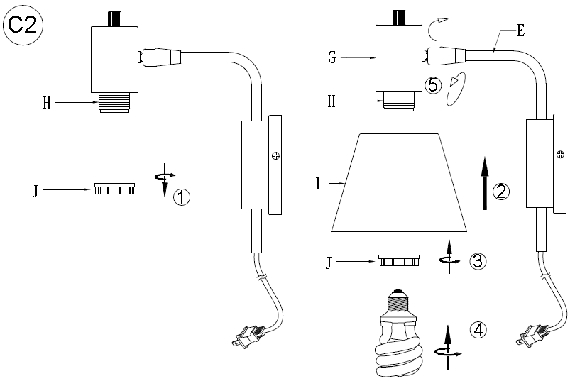

- Unscrew the Socket Ring (J) from the Socket (H).
- Place the Lamp Shade (I) onto the Socket (H).
- Secure the Lamp Shade (I) by turning the Socket Ring (J) onto the Socket (H) in a clockwise direction until tight.
- Insert the specified light bulb into the Socket (J). DO NOT EXCEED THE SPECIFIED WATTAGE.
- If needed, adjust the Lamp Shade (I) to the desired position by gently moving the Lamp Arm (E) to left or right by hand until it is determined.
- If needed, adjust the Lamp Shade (I) to the desired angle by gently moving the Socket Cup (G) by hand until it is determined.

Care instructions:
- Wipe clean with a soft, dry cloth or static duster.
- Always avoid the use of harsh chemicals or abrasive cleaners as they may cause damage to the fixture’s finish.

Thank you for your purchase
2550 N.W. Nicolai Street, Portland Oregon 97210 Customer Service: 888 401-1900 rejuvenation.com

