Cylinder Collection Task Floor Lamp
Assembly Instructions
COUNTRY OF DESTINATION: US/CN UK/EU/AUS MIDDLE EAST

IMPORTANT SAFETY INSTRUCTIONS:
- This portable luminaire has a polarized plug (one blade is wider than the other) as a safety feature to reduce the risk of electric shock. This plug will fit in a polarized outlet only one way. If the plug does not fit fully in the outlet, reverse the plug. If it still does not fit, contact a qualified electrician. Never use with an extension cord unless plug can be fully inserted. Do not alter the plug. Do not attempt to defeat this safety feature.
- These instructions are provided for your safety. It is very important that they are read carefully and completely before beginning the assembly and installation of this lighting fixture.
- This fixture has been rated for up to one (1) 6o-watt maximum TYPE A standard incandescent light bulb (not included), (1) 5-watt led bulb (included) or one (1) 13-watt compact fluorescent light bulb (not included). To avoid the risk of fire, do not exceed the recommended wattage.
- Use with approved REJUVENATION Shades only, having a minimum opening diameter of 3-1/2 inches and a minimum lamp-to-shade spacing of 2-1/2 inches.
- This lamp is meant for indoor use.
- Save these instructions.

WARNING:
- To reduce the risk of fire, electrical shock or personal injury, always turn off and unplug the light fixture and allow it to cool prior to replacing light bulb.
- Do not touch bulb when fixture is turned on. Do not look directly at lit bulb.
- Keep flammable materials away from lit bulb.

PRE-ASSEMBLY
- Remove all parts and hardware from box along with any plastic protective packaging.
- Do not discard any contents until after assembly is complete to avoid accidentally discarding small parts or hardware.

Parts Included:
(1) Metal Cap (A)
(1) Lower Tube (B)
(1) Knurled Nut (C)
(1) Upper Tube (D)
(1) Socket (E)
(1) Lamp Shade (F)
(1) Socket Ring (G)

TO ASSEMBLE:

- Take out the Socket Ring (G) from the package.
- Place the Lamp Shade (F) onto the Socket (E). Then, secure the Lamp Shade (F) by turning the Socket Ring (G)
onto the Socket (E) in a clockwise direction until tight.
- Insert one (1) 6o-watt maximum TYPE A standard incandescent light bulb (not included), (1) 5-watt led bulb (included) or one (1) 13-watt compact fluorescent light bulb (not included) into the Socket (E). DO NOT EXCEED THE SPECIFIED WATTAGE.
- If needed, loosen the Knurled Nut(C) at the top end of the Lower Tube (B) and adjust the Upper Tube (D) to the desired height until it is determined. Secure the Upper Tube (D) by turning the Knurled Nut(C) in a clockwise direction by hand until tight.
- If needed, adjust the Lamp Shade (F) to the desired angle by gently rotating the Metal Cap (A) or moving the Metal Cap (A) up and down by hand until it is determined.
- Plug fixture into the proper electrical outlet and test fixture.
- Assembly is complete.

CARE INSTRUCTIONS:
- Wipe clean with a soft, dry cloth or static duster.
- Always avoid the use of harsh chemicals or abrasive cleaners as they may cause damage to the fixture’s finish.

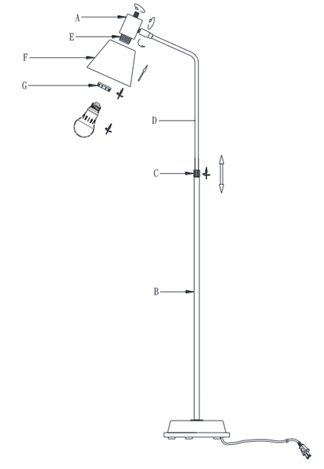

Thank you for your purchase

2550 N.W. Nicolai Street, Portland Oregon 97210 Customer Service: 888 401-1900 rejuvenation.com

